


Equality, Diversity and Inclusion Annual Report 2024

Contents
Contents 2
Introduction 3
1.1 Our Motivation 4
1.2 Our Purpose 4
1.3 Our Values 4
Executive Summary 5
2.1 Key Achievements 5
2.1.1 Advances in Leadership and Culture Workstream 5
2.2.2 Advances in Data-Driven Change Workstream 6
2.1.2 Advances in Fair Opportunities for All Workstream 6
2.2 Workforce Race Equality Standard (WRES) and Workforce Disability Equality Standard (WDES) Insights 7
2.3 Gender Pay Gap 2023 7
2.4 Key Areas for Development 7
2.5 Ongoing and Planned Interventions: 8
2.6 Recommendations: 8
Introduction to Moorfields Eye Hospital’s EDI Programme 8
3.1 Introduction of the new EDI programme: 8
3.2 Leadership and Culture 9
3.2.1 Key Highlight 9
3.3 Data-Driven Change 9
3.3.1 Key Highlight 10
3.4 Fair Opportunities for All 10
3.4.1 Key Highlight 10
3.5 Conclusion 10
Workforce EDI Data Reporting 11
4.1 Introduction 11
4.2 WRES Data Comparison: 2023 vs. 2024 11
4.3 WDES Data Comparison: 2023 vs. 2024 12
4.4 Action Plan Comparison: 2023 vs. 2024 13
4.4.1 Key Highlights for WRES and WDES Action Plan: 14
4.5 Key Issues Highlighted 14
4.6 Conclusion 15
Gender Pay Gap (2023) 15
5.1 Introduction 15
Appendix A: 20
EDI Programme Workstreams and Initiatives 20
Appendix B: 21
Workstreams and Objectives 21
Appendix C: 22
EDI Roadmap 22

Introduction

Moorfields Eye Hospital (MEH) is pleased to present its annual Equality, Diversity, and Inclusion (EDI) Workforce Data Report, covering the period from 01 April 2023 to 31 March 2024. Our new EDI vision is "Equity in Action," demonstrating our commitment to creating an inclusive culture where every individual feels respected, valued, and able to thrive. This report provides insights into our workforce demographics and highlights the steps we are taking to build an equitable, diverse, and inclusive workplace. As a leading provider of ophthalmic care, education, and research, MEH is dedicated to ensuring that our staff represents the communities we serve. We aim to eliminate discrimination, foster good relations, and promote opportunities for all, embedding EDI into every aspect of our service empowered by our EDI vision and Trust values.

1.1 Our Motivation
Our motivation is what inspires all of us day-to-day, and our strategy is firmly rooted in this belief. The experience of losing sight or having serious disturbances of vision is distressing and can be isolating and costly for those affected. Putting people with sight loss or disturbed vision at the centre of care is essential if we are to support their needs.
Providing a working environment that attracts and retains the best people and where individuals feel supported, challenged and empowered is fundamental to achieving our organisational aims. Discrimination plays no part in a healthy, inclusive culture and will not be tolerated in the Trust.

1.2 Our Purpose
Working together to discover, develop and deliver excellent eye care, sustainably and at scale.

1.3 Our Values

    - Excellence: is at the heart of Moorfields’ purpose and history. It is also fundamental to our future as we innovate at the forefront of eyecare, delivering the best care and experience.
    - Equity: means everyone can expect that we will do our best for them – our patients, staff and system partners – providing appropriate, accessible, excellent and sustainable care based on clinical need. Everyone can be confident their voice is listened to in decisions about their care.
    - Kindness: means we are friendly and considerate – treating everyone with respect and going out of our way to reassure and give confidence.

Executive Summary

This EDI Annual Report highlights Moorfields Eye Hospital’s progress in advancing equity, diversity, and inclusion during the reporting period of 2023-2024. It provides an overview of our strategic initiatives, key achievements, and ongoing challenges as we continue our journey towards fostering an inclusive workplace and equitable services.

A new EDI programme was introduced in alignment with our new Trust strategy. Under this new programme, we have three key workstreams:
- Leadership and Culture
- Data-Driven Change
- Fair Opportunities for All

Key Achievements

Advances in Leadership and Culture Workstream

- Anti-Racism Charter: We took significant steps toward becoming an anti-racist organisation by signing the Unison Anti Racism Chart and the supporting delivery programme is mapped to our EDI programme. We are now on a journey to embed anti-racism into our leadership and training programs. This initiative will improve the understanding of race related issues.
- Executive EDI Objectives: Executive team members now have EDI objectives to ensure that EDI is sponsored and role-modelled by the senior leadership of the Trust with clear accountabilities.
- Executive EDI floor walking: Detailed plan developed for executive EDI floor walking. These EDI-focused walkabouts will be used to promote the EDI programme and also to identify opportunities to enhance equity, diversity, and inclusion in the workplace. The walk will also be used for listening and learning about employees' experiences, particularly those from underrepresented or marginalized groups.

Advances in Data-Driven Change Workstream

- EDI Dashboard: A comprehensive EDI dashboard is being developed to track key performance metrics such as pay gaps, workforce demographics, and representation. This tool will enhance transparency and accountability in our EDI efforts. The first cut of the dashboard has already been released.
- "Share Not Declare" Campaign: A campaign aimed at improving the accuracy of demographic data has been launched, encouraging staff to voluntarily disclose protected characteristics, ensuring a clearer picture of our workforce diversity. This initiative will also help the Trust work on workplace adjustments and review our policies with a reflection on EDI.
- WRES and WDES Data Analysis: Analysis of Workforce Race Equality Standard (WRES) and Workforce Disability Equality Standard (WDES) data allows us to track disparities in the workplace and guide strategic interventions. This ongoing data collection informs our targeted efforts to close pay gaps and improve representation at all levels of the organisation​.

Advances in Fair Opportunities for All Workstream

- Career Sponsorship Program: Launched to support underrepresented staff, particularly Black, Asian, and minority ethnic colleagues, this program provides mentorship and development opportunities, contributing to a more diverse talent pipeline.
- Leadership Academy Program (LAP): Tailored leadership development for staff with disabilities was rolled out, with positive feedback from participants, increasing accessibility to leadership roles.
- Recruitment practices: Reviewing a national toolkit, ‘No More Tick Boxes’ and embedding the best practices for recruitment, succession planning and talent management.

Workforce Race Equality Standard (WRES) and Workforce Disability Equality Standard (WDES) Insights

- Representation and Disparities: BME staff representation slightly increased to 57.6% in 2024, but challenges remain in senior-level positions. For disabled staff, representation improved to 3.1%, though under-reporting continues to affect data accuracy.
- Disciplinary Process and Career Progression: Improvements were noted in the fairness of disciplinary processes for BME staff. However, both BME and disabled staff still face barriers in career progression, with lower levels of trust in equal opportunities for advancement.
- Bullying and Harassment: Despite slight improvements, reports of bullying and harassment remain high for BME and disabled staff, emphasising the need for ongoing intervention.

Gender Pay Gap 2023

- Pay Gaps: The mean gender pay gap increased to 17.86%, while the median pay gap stood at 16.52%. The gender pay disparity is largely due to the underrepresentation of women in senior and higher-paid roles, with women comprising 68% of the workforce but only 54.16% of the highest pay quartile.
- Bonus Pay Gap: The bonus pay gap increased to 7.13%, primarily driven by the Clinical Excellence Awards (CEAs), which disproportionately benefit male consultants.

Key Areas for Development

- Recruitment: WRES indicator 2 shows a decline in our position compared to last year and currently forms part of a recruitment outcome review under the EDI programme.
- Staff Survey and Pulse Survey: Feedback indicates that 63% of the workforce in the staff survey recommended the organisation as a place of work, whereas in the Pulse survey, it was only 54%.
- Board Representation: Representation of both BME and disabled staff at the board level decreased, highlighting an urgent need to diversify senior leadership.

Ongoing and Planned Interventions:

- EDS2022
- EHIA's new framework
- Anti-Racism and Well-Being initiative
- Leadership programme
- Anti-Racism and microaggression training
- Listening events with staff networks
- New Women’s staff network

Recommendations:

- Continue to drive the implementation of the EDI dashboard and improve data accuracy through campaigns like "Share Not Declare."
- Strengthen efforts to close pay gaps and ensure equitable access to career progression opportunities for underrepresented staff.
- Embed the Anti-Racism Charter across the organisation and enhance leadership accountability for fostering an inclusive workplace.

Introduction to Moorfields Eye Hospital’s EDI Programme

3.1 Introduction of the new EDI programme:

At Moorfields Eye Hospital, we are committed to fostering an environment where Equity, Diversity, and Inclusion (EDI) are integral to everything we do. Our new EDI programme and our new EDI vision, "Equity in Action," embodies this commitment by creating a workplace where every individual feels valued, safe, and empowered to reach their full potential. The programme is built around three core workstreams: Leadership and Culture, Data-Driven Change, and Fair Opportunities for All. Each workstream plays a critical role in addressing the specific challenges we face, driving positive, measurable outcomes, and ensuring that EDI principles are embedded throughout the organisation. We aim to create a culture where inclusivity and belongingness are at our focal point.

3.2 Leadership and Culture

The Leadership and Culture workstream focuses on embedding EDI values at the highest levels of leadership. Senior leaders are expected to act as champions of inclusivity, setting the tone for the rest of the organisation. This involves not only role-modelling inclusive behaviour but also engaging with staff through various means such as listening sessions, floor walks, and ongoing dialogue. Key initiatives under the workstream include:

- Anti-Racism Charter
- EDI Objectives for Exec Board
- Senior Leaders’ listening exercises and floor walks
- Support to Exec
- Building psychological safety
- Reverse mentoring
- Staff and ally networks

3.2.1 Key Highlight

The Leadership and Culture workstream has already achieved several milestones, including the signing of the Anti-Racism Charter and the successful rollout of the new EDI vision. These efforts have received positive feedback from staff and are helping to drive cultural change across the organisation​.

3.3 Data-Driven Change

The Data-Driven Change workstream is focused on leveraging data to identify and address inequities within the organisation. By collecting, analysing, and acting on data, Moorfields can ensure accountability, transparency, and ongoing improvement in its EDI efforts. This workstream involves several critical initiatives:
- Development of an EDI Dashboard
- Increased Declarations
- Use data to measure success and inform initiatives
- Improved data transparency
- Implement NHSE EDS 2022

3.3.1 Key Highlight:

The initial EDI Baseline data, which will evolve into the EDI dashboard, is in development and on track to be published in December 2024, and will serve as a critical tool for tracking and reporting on EDI progress. Additionally, the "Share Not Declare" campaign has been launched to improve staff confidence in disclosing personal information, leading to more accurate demographic data​ and informing reasonable adjustments toolkit including reviewing of policies and procedures.

3.4 Fair Opportunities for All

The Fair Opportunities for All workstream is dedicated to ensuring that recruitment, career development, and training opportunities are accessible and equitable for all staff. This workstream focuses on dismantling barriers to progression for underrepresented groups and fostering a culture where all employees have the tools and opportunities to succeed. Key initiatives include:
- Career Sponsorship
- Leadership Academy Programme
- Refresh diverse panels guidance
- L&D and education initiatives
- Succession planning and transparency of career development

3.4.1 Key Highlight:

The Fair Opportunities for All workstream has seen the successful implementation of the Career Sponsorship Programme and the Leadership Academy Programme, with positive feedback from participants. These initiatives are helping to break down barriers and create a more inclusive pathway for career progression at the Trust​.

3.5 Conclusion

Moorfields Eye Hospital's EDI Programme represents a comprehensive approach to building an inclusive, equitable organisation. Through the three key workstreams—Leadership and Culture, Data-Driven Change, and Fair Opportunities for All—we are making strides in creating a workplace where diversity is celebrated and all staff are empowered to thrive. As we continue to roll out these initiatives, we remain committed to transparency, accountability, and sustained progress toward our EDI goals.

Workforce EDI Data Reporting

4.1 Introduction

Below is the Workforce Race Equality Standard (WRES) and Workforce Disability Equality Standard (WDES) data and action plans for 2023 and 2024 at Moorfields Eye Hospital NHS Foundation Trust. It highlights key issues, provides insights from both datasets and compares progress between the two years, focusing on the overarching action plans and narrative shifts.

4.2 WRES Data Comparison: 2023 vs. 2024

Representation of BME Staff
- 2023: BME staff representation stood at 55.9%, with disparities in representation increasing at senior levels​.
- 2024: BME staff representation slightly increased to 57.6%, but the gap at senior levels persists. Addressing representation at the Very Senior Manager (VSM) level remains a priority​.
Likelihood of White Applicants Being Appointed
- 2023: The relative likelihood of white applicants being appointed from shortlisting improved from previous years (1.21)​.
- 2024: A decline in this indicator was noted, with the likelihood rising again to 1.47, signalling a reversal of previous improvements. This issue is now part of a recruitment outcome review​.
Likelihood of BME Staff Entering Formal Disciplinary Processes
- 2023: This indicator improved, with BME staff being less likely than white staff to enter disciplinary processes (0.98)​.
- 2024: Further improvement was observed, with the ratio now at 0.76, indicating continued positive progress​.
Access to CPD and Non-Mandatory Training
- 2023: The ratio was more balanced, with improvements in access to CPD for BME staff​.
- 2024: Access for BME staff worsened, with the ratio rising to 1.4, suggesting declining inclusivity in non-mandatory training​.
Harassment, Bullying, and Abuse
- 2023: Reports of bullying and harassment against BME staff remained higher than their white colleagues, with little improvement​.
- 2024: There was a slight reduction in reported harassment and bullying for BME staff, from 32.5% to 30.4%, but the issue persists​.
Board Representation
- 2023: Board representation of BME staff remained stable at 10%​.
- 2024: Board representation decreased to 5.6%, a key issue highlighted as an area needing immediate focus​.

4.3 WDES Data Comparison: 2023 vs. 2024

Representation of Disabled Staff
- 2023: Disabled staff representation was 2.7% at Moorfields, with national averages higher​.
- 2024: Representation increased slightly to 3.1%, but the overall number of declared disabilities remains low, signalling under-reporting​.
Likelihood of Non-Disabled Applicants Being Appointed
- 2023: The relative likelihood of non-disabled applicants being appointed from shortlisting remained high (1.3), though improved from previous years​.
- 2024: The likelihood worsened considerably, rising to 3.3, highlighting the growing disparity between disabled and non-disabled applicants​.
Bullying, Harassment, and Abuse
- 2023: Disabled staff continued to report higher rates of harassment and bullying from patients, managers, and colleagues, compared to non-disabled staff​.
- 2024: Reports of bullying and harassment among disabled staff saw a slight reduction, but rates are still concerning, especially when compared to their non-disabled counterparts​.
Equal Opportunities for Career Progression
- 2023: Disabled staff’s trust in career progression had improved slightly (49.7%)​.
- 2024: Trust levels worsened to 36.8%, showing a significant drop in disabled staff’s confidence in the Trust's commitment to equal opportunities​.
Board Representation of Disabled Staff
- 2023: There was a decline in disabled board representation, with the loss of a Non-Executive Director declaring a disability​.
- 2024: Disabled board representation remained low, with 0% of voting board members declaring a disability​.

4.4 Action Plan Comparison: 2023 vs. 2024

The action plan for 2024 reflects on the action plan of 2023 and also introduces new initiatives. The action plan reflects the progress rate for 2023, ensuring a realistic view of last year’s plans. The new Action plan for 2024 comprises of actions and initiatives linked to the three workstreams under the EDI programme with key metrics on how we will measure the success.

4.4.1 Key Highlights for WRES and WDES Action Plan:

WRES
- 2023: The 2023 plan emphasised increasing BME representation at senior levels, enhancing access to CPD, and tackling bullying and harassment through the Active Bystander initiative​.
- 2024: The 2024 plan includes continuing the Career Sponsorship Programme and increasing leadership accountability via anti-racism training and reverse mentoring for senior executives. The Trust-wide anti-racism charter is a key milestone​.
WDES
- 2023: The focus was on improving disability declaration rates through campaigns, embedding the Leadership Academy Programme, and revising the recruitment process to eliminate bias​.
- 2024: The 2024 plan maintains these objectives but adds a focus on expanding health passports and embedding reasonable adjustments guidance with the help of the ‘Share not Declare’ campaign. There is also a greater emphasis on leadership engagement and support for disabled colleagues​.

4.5 Key Issues Highlighted

Under-Declaration
WDES data show persistent issues with the under-reporting of disability. The "Share Not Declare" campaign aims to address this, and the plan is to support the Trust's ability to develop fully representative and responsive policies​ and support for disabled colleagues.
Career Progression
Disabled staff reported a significant drop in trust regarding career progression opportunities in 2024 compared to 2023. Similarly, BME staff continue to face challenges in advancing to senior positions, with representation decreasing at higher levels​.
Bullying and Harassment
Bullying and harassment remain significant issues for both disabled and BME staff. While the rates have decreased slightly in 2024, they are still notably higher than for their white and non-disabled colleagues​.
Board Representation
Both BME and disabled staff representation at the board level have worsened, highlighting the need for focused interventions to ensure a diverse leadership pipeline​.

4.6 Conclusion

Moorfields Eye Hospital's WRES and WDES data for 2024 highlights ongoing challenges in addressing racial and disability disparities, particularly in career progression, harassment, and board representation. While progress has been made in some areas, such as improved disciplinary fairness for BME staff and the successful rollout of leadership programs for disabled colleagues, many issues remain unresolved. The action plans for 2024 build on the foundations laid in 2023 but with a renewed focus on leadership accountability and more robust support for underrepresented groups. Ensuring that these plans are effectively implemented will be crucial to driving sustained improvement.

Gender Pay Gap (2023)

5.1 Introduction

The data reported shows the pay gap as at 31st March 2023, as required by the Regulations.

Gender Pay Gap
In 2023, the average pay for a male employee was £27.10 per hour which equated to £4.84 (17.86%) higher than the average female hourly rate, which was marginally higher than 2022. The median hourly rate gap was comparatively lower at £4.00 (16.52%) per hour.
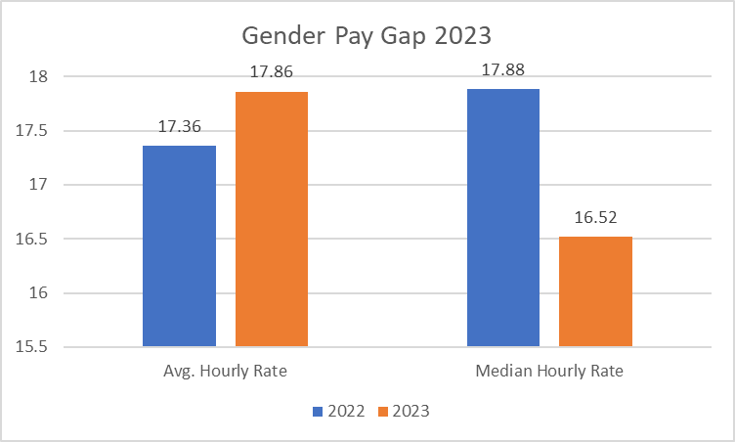
Figure 1: Average and Median Gender Pay Gap 2023 compared with 2022

The cause of the gender pay gap is multifaceted. Looking at the percentage of women in the Moorfield’s workforce at 68% (consistent with representation across the NHS) this is considerably higher than the UK workforce at 57%. Our data shows there are more women in lower paid roles /occupations, see staff group breakdowns below. Women are also more likely to work part-time, which is generally less well paid than full-time work on a per hour basis (28% for women compared to 20% for men in the Trust, compared with 38% for women and 14% for men across the UK), and to take time out of the labour force for caring responsibilities (58% of carers in the UK are women compared to 42% being men) . These factors limit women’s labour market experience and progression; the gender pay gap widens significantly after women have children.

Compared with 2022 the Trust headcount has increased by 72 in total, of which there are 44 more Administrative and Clerical and 21 more Nursing & Midwifery Registered Female staff in these roles.
Staff Overview | Headcount |  | % in Band
Staff Group | Female | Male | Female | Male
Add Prof Scientific and Technic | 167 | 66 | 72% | 28%
Additional Clinical Services | 263 | 120 | 69% | 31%
Administrative and Clerical | 573 | 234 | 71% | 29%
Allied Health Professionals | 42 | 8 | 84% | 16%
Estates and Ancillary | 2 | 33 | 6% | 94%
Healthcare Scientists | 33 | 22 | 60% | 40%
Medical and Dental | 157 | 185 | 46% | 54%
Nursing and Midwifery Registered | 375 | 77 | 83% | 17%
Students | 3 | 1 | 75% | 25%
Grand Total | 1615 | 746 | 68% | 32%
Table 1: Staff Group Breakdown AfC

Staff Overview | Headcount |  | % in Band
Staff Group | Female | Male | Female | Male
Consultant | 63 | 100 | 39% | 61%
Non-consultant career grade | 71 | 60 | 54% | 46%
Trainee grades | 23 | 25 | 48% | 52%
Grand Total | 157 | 185 | 46% | 54%
Table 2: Staff Group Breakdown Medical

Whilst women make up 68% of our workforce, they are overrepresented in the Lower, Lower Middle and Upper Middle pay quartiles and underrepresented in the Upper pay quartile. This has improved only slightly compared to 2022 but in role there are 15 more Females in the Upper pay quartile and 8 fewer Males resulting in an almost 2% shift in representation.

Quartile | Female | Male | Female % | Male %
0-25% | 397 | 158 | 71.53 | 28.47
25%-50% | 413 | 164 | 71.58 | 28.42
50%-75% | 451 | 155 | 74.42 | 25.58
75%-100% | 319 | 270 | 54.16 | 45.84
Table 3: Gender by Pay Quartile

Medical vs. Non-Medical Gender Pay Gap
Band Groupings | Female |  | Male |  | GPG
Band Groupings | Mean Hrly Rate | Median Hrly Rate | Mean Hrly Rate | Median Hrly Rate | Mean GPG | Median GPG
Band 1-4 | £14.13 | £14.35 | £14.45 | £14.35 | 2.21% | 0.00%
Band 5-7 | £22.91 | £22.74 | £23.34 | £24.53 | 1.84% | 7.30%
Bands 8-9 | £34.81 | £31.77 | £35.64 | £31.87 | 2.33% | 0.31%
Medical Staffing | £37.80 | £35.37 | £41.87 | £45.17 | 9.72% | 21.70%

Table 4: Medical vs. Non-Medical Gender Pay Gap

When considering the data on a more granular level, it is clear that the main driver of the gender pay gap at MEH is the difference our consultant workforce makes on pay across the organisation.

Whilst the overall percentage comparison of men and women at a medical grade (54% and 46% respectively) has moved closer than in 2022 , the split at consultant grade has remained at 60% and 40% in favour of men. In addition, the women in the medical grades form part of a much larger population of women when looking at the gap at the organisational level (as the Trust is 68% female). Consequently, their effect on female average pay is less than male consultant pay is on male average pay.

Ethnicity Pay Gap (EPG)

- Whilst not required to report on it formally, the Trust continues our practice of analysing our pay data by ethnicity as well as gender.
- The Mean EPG has increased from 13.20% in 2022 to 14.17% in 2023. The biggest increase in the EPG was in Bands 8–9 where it went from 7.28% to 9.93%.
- Table 5 shows that EPG is primarily driven by pay at the AfC Bands 8-9 and within the Medical Staffing workforce. This reflects our underrepresentation rates for Black, Asian and Minority Ethnic (BME) colleagues within Band 7, and similarly at Bands 8c and above.

Band Groupings | BME |  | WHITE |  | EPG
Band Groupings | Mean Hrly Rate | Median Hrly Rate | Mean Hrly Rate | Median Hrly Rate | Mean EPG | Median EPG
Band 1-4 | £ 14.35 | £ 14.35 | £14.49 | £14.35 | 0.97% | 0.00%
Band 5-7 | £ 22.86 | £ 22.87 | £23.37 | £24.53 | 2.18% | 6.77%
Bands 8-9 | £ 32.83 | £ 31.71 | £36.45 | £32.50 | 9.93% | 2.43%
Medical Staffing | £ 39.40 | £ 40.60 | £43.30 | £47.69 | 9.01% | 14.87%

Table 5: Pay by Ethnicity, analysed by pay band groupings as of 31 March 2023

Recommendations and Actions
The recommendations below have been developed to assist specifically in closing the gap re both gender and ethnicity. It should be noted that this is a process that cannot achieve immediate corrective impact but rather a gradual reduction in the disparity. There are historical issues regarding representation within medical staffing and length of service, which will only be corrected over time. Some of the actions include introducing a Women’s Staff Network Group to ensure challenges around succession and equality are given a suitable platform, implementing the recommendations within the “Mind the Gap” report and following the successful launch of the first Career Sponsorship programme in 2023 the Trust will look to roll out further cohorts with the aspiration of enhancing the promotional opportunities for BME colleagues.

Appendix A:

EDI Programme Workstreams and Initiatives

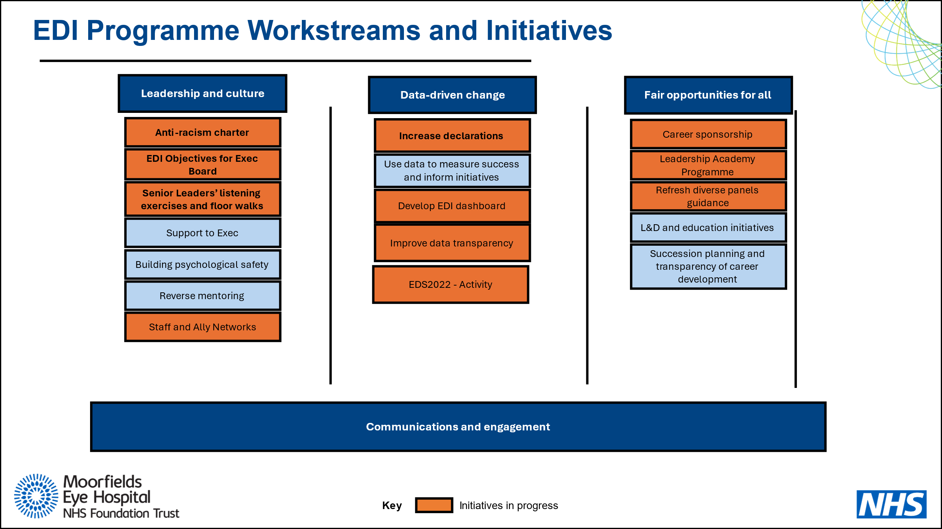

Appendix B:

Workstreams and Objectives

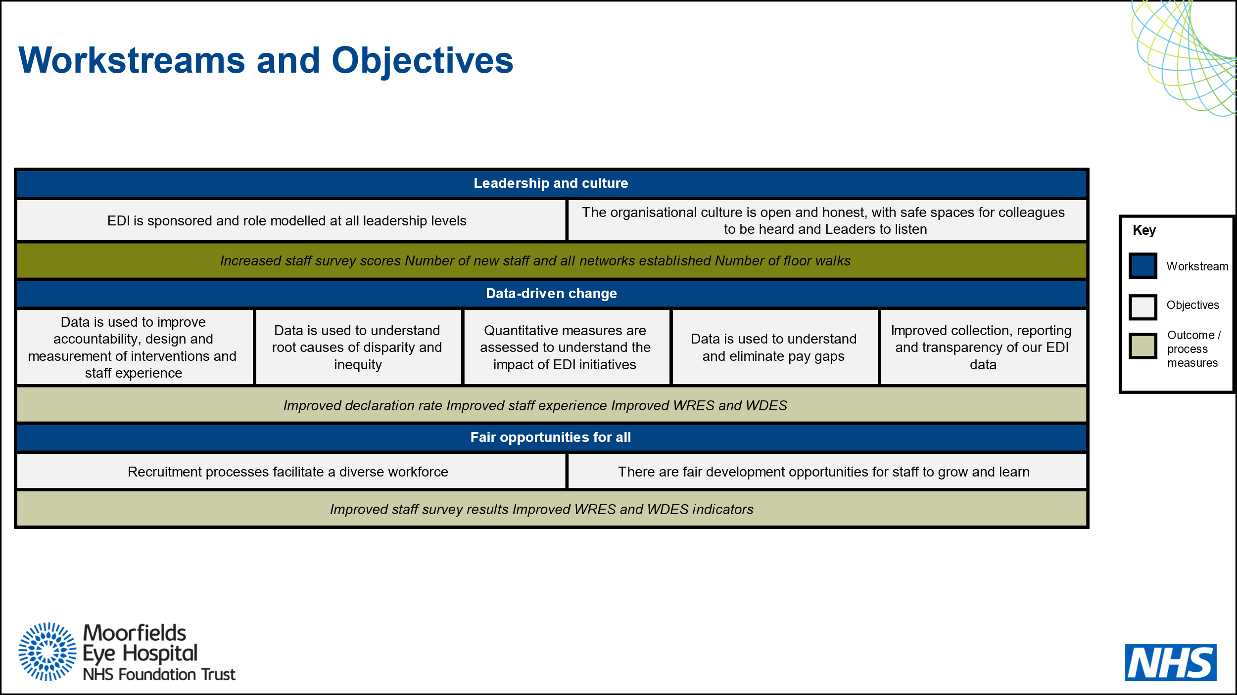

Appendix C:

EDI Roadmap
